Do-It-Yourself Dissemination Tool Kit – Elected Officials: Executive Summary Example
Format: E-mail to elected official stakeholder with the Executive Summary

Subject: Address traditional risk factors to prevent serious diseases in adults with HIV

Dear Sen. Cardin and Sen. Van Hollen,
Below is an Executive Summary of a study published this evening that demonstrates the need to address and prevent risk factors such as cigarette smoking, elevated total cholesterol, hypertension, and alcohol use among adults who are aging with HIV in order to avoid a substantial burden of cancer, heart attack, end-stage liver, and end-stage renal disease.
These findings are an important contribution to the evidence suggesting that HIV care cannot end with a suppressed viral load; but rather once HIV is controlled the work to address risk factors traditionally associated with these age-related outcomes begins.
This study is an example of Johns Hopkins Bloomberg School of Public Health-led multidisciplinary science that was NIH-funded and impacts the lives of Marylanders with HIV. Thank you for your continued support of the NIH.
The views expressed here are my own and do not necessarily reflect the policies or positions of Johns Hopkins University.

Sincerely,
Keri N Althoff, PhD, MPH
Associate Professor
Department of Epidemiology, Johns Hopkins Bloomberg School of Public Health
Joint Appointment in the Johns Hopkins Sidney Kimmel Cancer Center

@kerinalthoff on Twitter
Pronouns: She/Her/Hers

EXECUTIVE SUMMARY: Traditional risk factors must be addressed to prevent serious diseases in adults with HIV
In a study published in The Lancet HIV, a multidisciplinary team of researchers showed that eliminating traditional lifestyle factors is essential to preserving the health of adults with HIV.
The study showed 24% of cancers and 37% of myocardial infarctions among adults with HIV could be avoided by eliminating cigarette smoking in this population. An additional 44% of myocardial infarctions could be avoided by reducing total cholesterol to (<240 mg/dL) and 42% could be avoided by reducing hypertension. Reducing hypertension would also avoid 39% of end-stage renal disease diagnoses. Eliminating hepatitis C virus infection would avoid 30% of end-stage liver disease diagnoses.
The study was conducted by following upwards of 60,000 adults with HIV in the North American AIDS Cohort Collaboration on Research and Design (NA-ACCORD). The roles of smoking, elevated total cholesterol, hypertension, diabetes, chronic kidney disease, hepatitis C and B infection, as well as markers of HIV disease progression (clinical AIDS diagnosis, CD4 count, and HIV viral load) were investigated on the following four diseases: cancer, myocardial infarctions, end-stage renal disease, and end-stage liver disease. Adults with HIV have a greater burden of these four diseases compared to adults without HIV. These findings provide evidence about the reduction of disease outcomes that would result if a risk factor was eliminated.
The authors conclude a substantial proportion of non-AIDS-defining cancers, myocardial infarction, end-stage liver disease, and end-stage renal disease could be prevented with interventions on traditional risk factors. Preventing and screening for these risk factors will require sustainable care models to implement such interventions during the decades of life of adults with HIV.
Lead investigator, Keri N Althoff, PhD, MPH, Associate Professor of Epidemiology at the Johns Hopkins Bloomberg School of Public Health comments “There is an urgency for resources and care models aimed at reducing traditional risk factors in order to protect the health of people as they live and age with HIV.”

This study was funded through a K01 Career Development Award from the National Institute of Allergy and Infectious Diseases, National Institutes of Health (NIH) and would not have been possible without support from the HIV & Aging R24, Johns Hopkins Center for AIDS Research, the and the numerous NIH institutes and Canadian provincial governments that support the NA-ACCORD and IeDEA.
For inquiries, contact Dr. Keri N Althoff at kalthoff@jhu.edu or 312-479-1174 (mobile). Follow @kerinalthoff on Twitter to see a thread reporting the results from this study.

Althoff KN, et al. The contributions of traditional and HIV-related risk factors on non-AIDS-defining cancer, myocardial infarction, and end-stage liver and renal diseases in adults with HIV in the US and Canada: A collaboration of cohort studies. The Lancet HIV, 2019. Available at: https://www.thelancet.com/journals/lanhiv/article/PIIS2352-3018(18)30295-9/fulltext.

Population attributable fraction (%) is interpreted as:
the proportion of the disease that could be avoided
if the risk factor (y axis) was eliminated.
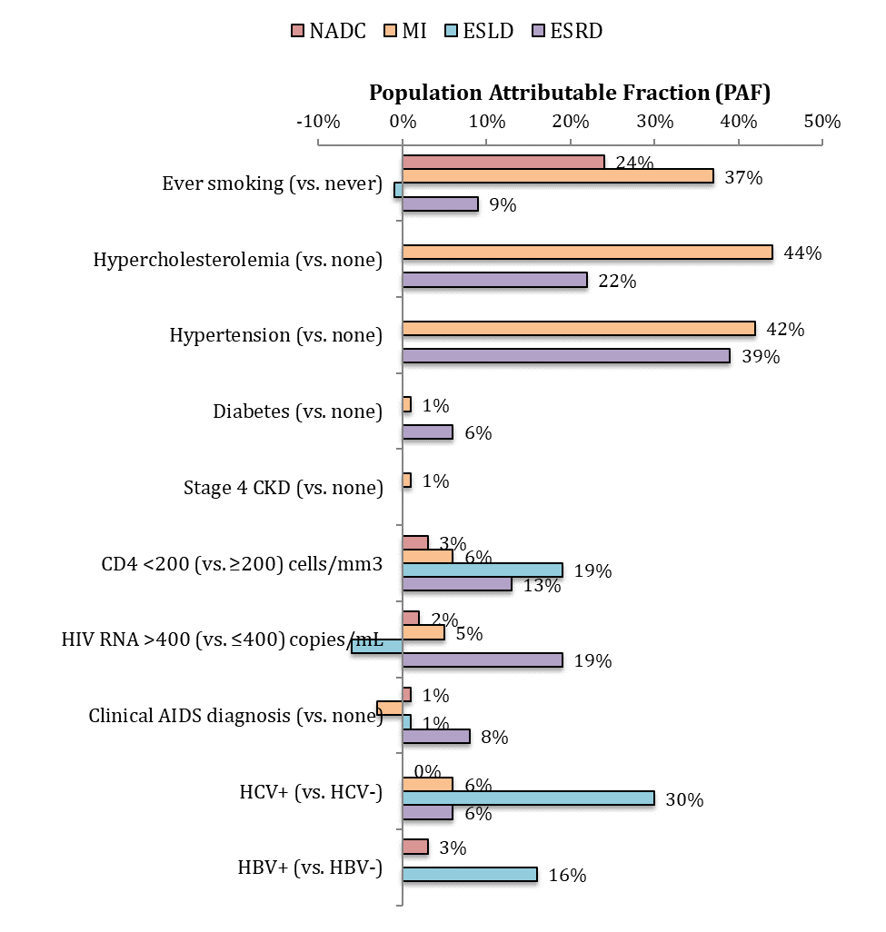
Disease abbreviations:
- NADC = non-AIDS-defining cancer
- MI = myocardial infarction
- ESLD = end-stage liver disease
- ESRD = end-stage renal disease

